Wisdom Teeth, Why Extract?
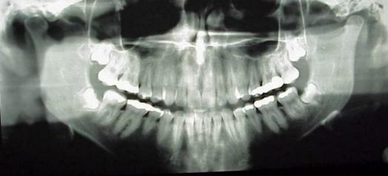

As a dentist, I am quite frequently asked about the reasons to extract or not to extract wisdom teeth. The answer is multifaceted. Few people have the jaw size and structure to accommodate the wisdom teeth. When wisdom teeth only partially come in or are partly or fully covered by tissue and bone, a number of problems may result. These include: gum infections around the wisdom teeth, decaying of the wisdom teeth and/or decaying of the teeth in front of the wisdom teeth.
The lower jaw is almost “L” shaped. The wisdom teeth sometimes come in at all sorts of varying angles. When this occurs the wisdom teeth may become lodged behind the second molar and only partially erupt. This creates a situation where the gum may cover half of the wisdom tooth or there may be an opening between the two teeth and food will become lodged there. Another major problem with either erupted or partially erupted wisdom teeth is the difficulty in cleaning them. Due to being so far back in the mouth and the positioning/angle of the tooth, food and plaque can be left behind causing bacteria to gather in the area which has the potential to cause operculitis (a painful infection in the gums) and/or tooth decay. Infections of lower wisdom teeth can result in swelling of the floor of the mouth and cause a condition called Ludwig’s Angina. Ludwig’s Angina restricts the ability to breathe and often results in death without appropriate intervention. Impacted (un-erupted) wisdom teeth can also weaken the jaw, making it prone to fracture.
Wisdom teeth are best and most easily removed when a patient is in their teens or early twenties before the roots are fully formed and the bone begins to stiffen and makes healing and recovery minimal. Most patients, barring any complications, will be eating and feeling back to normal in two to three days. I encourage my patients to take a long weekend to rest up and that is usually all that is needed.
Wisdom teeth can be removed under local anesthesia (numbing) or in some cases a patient or the dentist may prefer the patient be sedated. Talk to your dentist if you think you may need your wisdom teeth taken out and to find out about possible sedation options available.

