Why Invisalign?

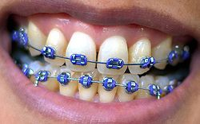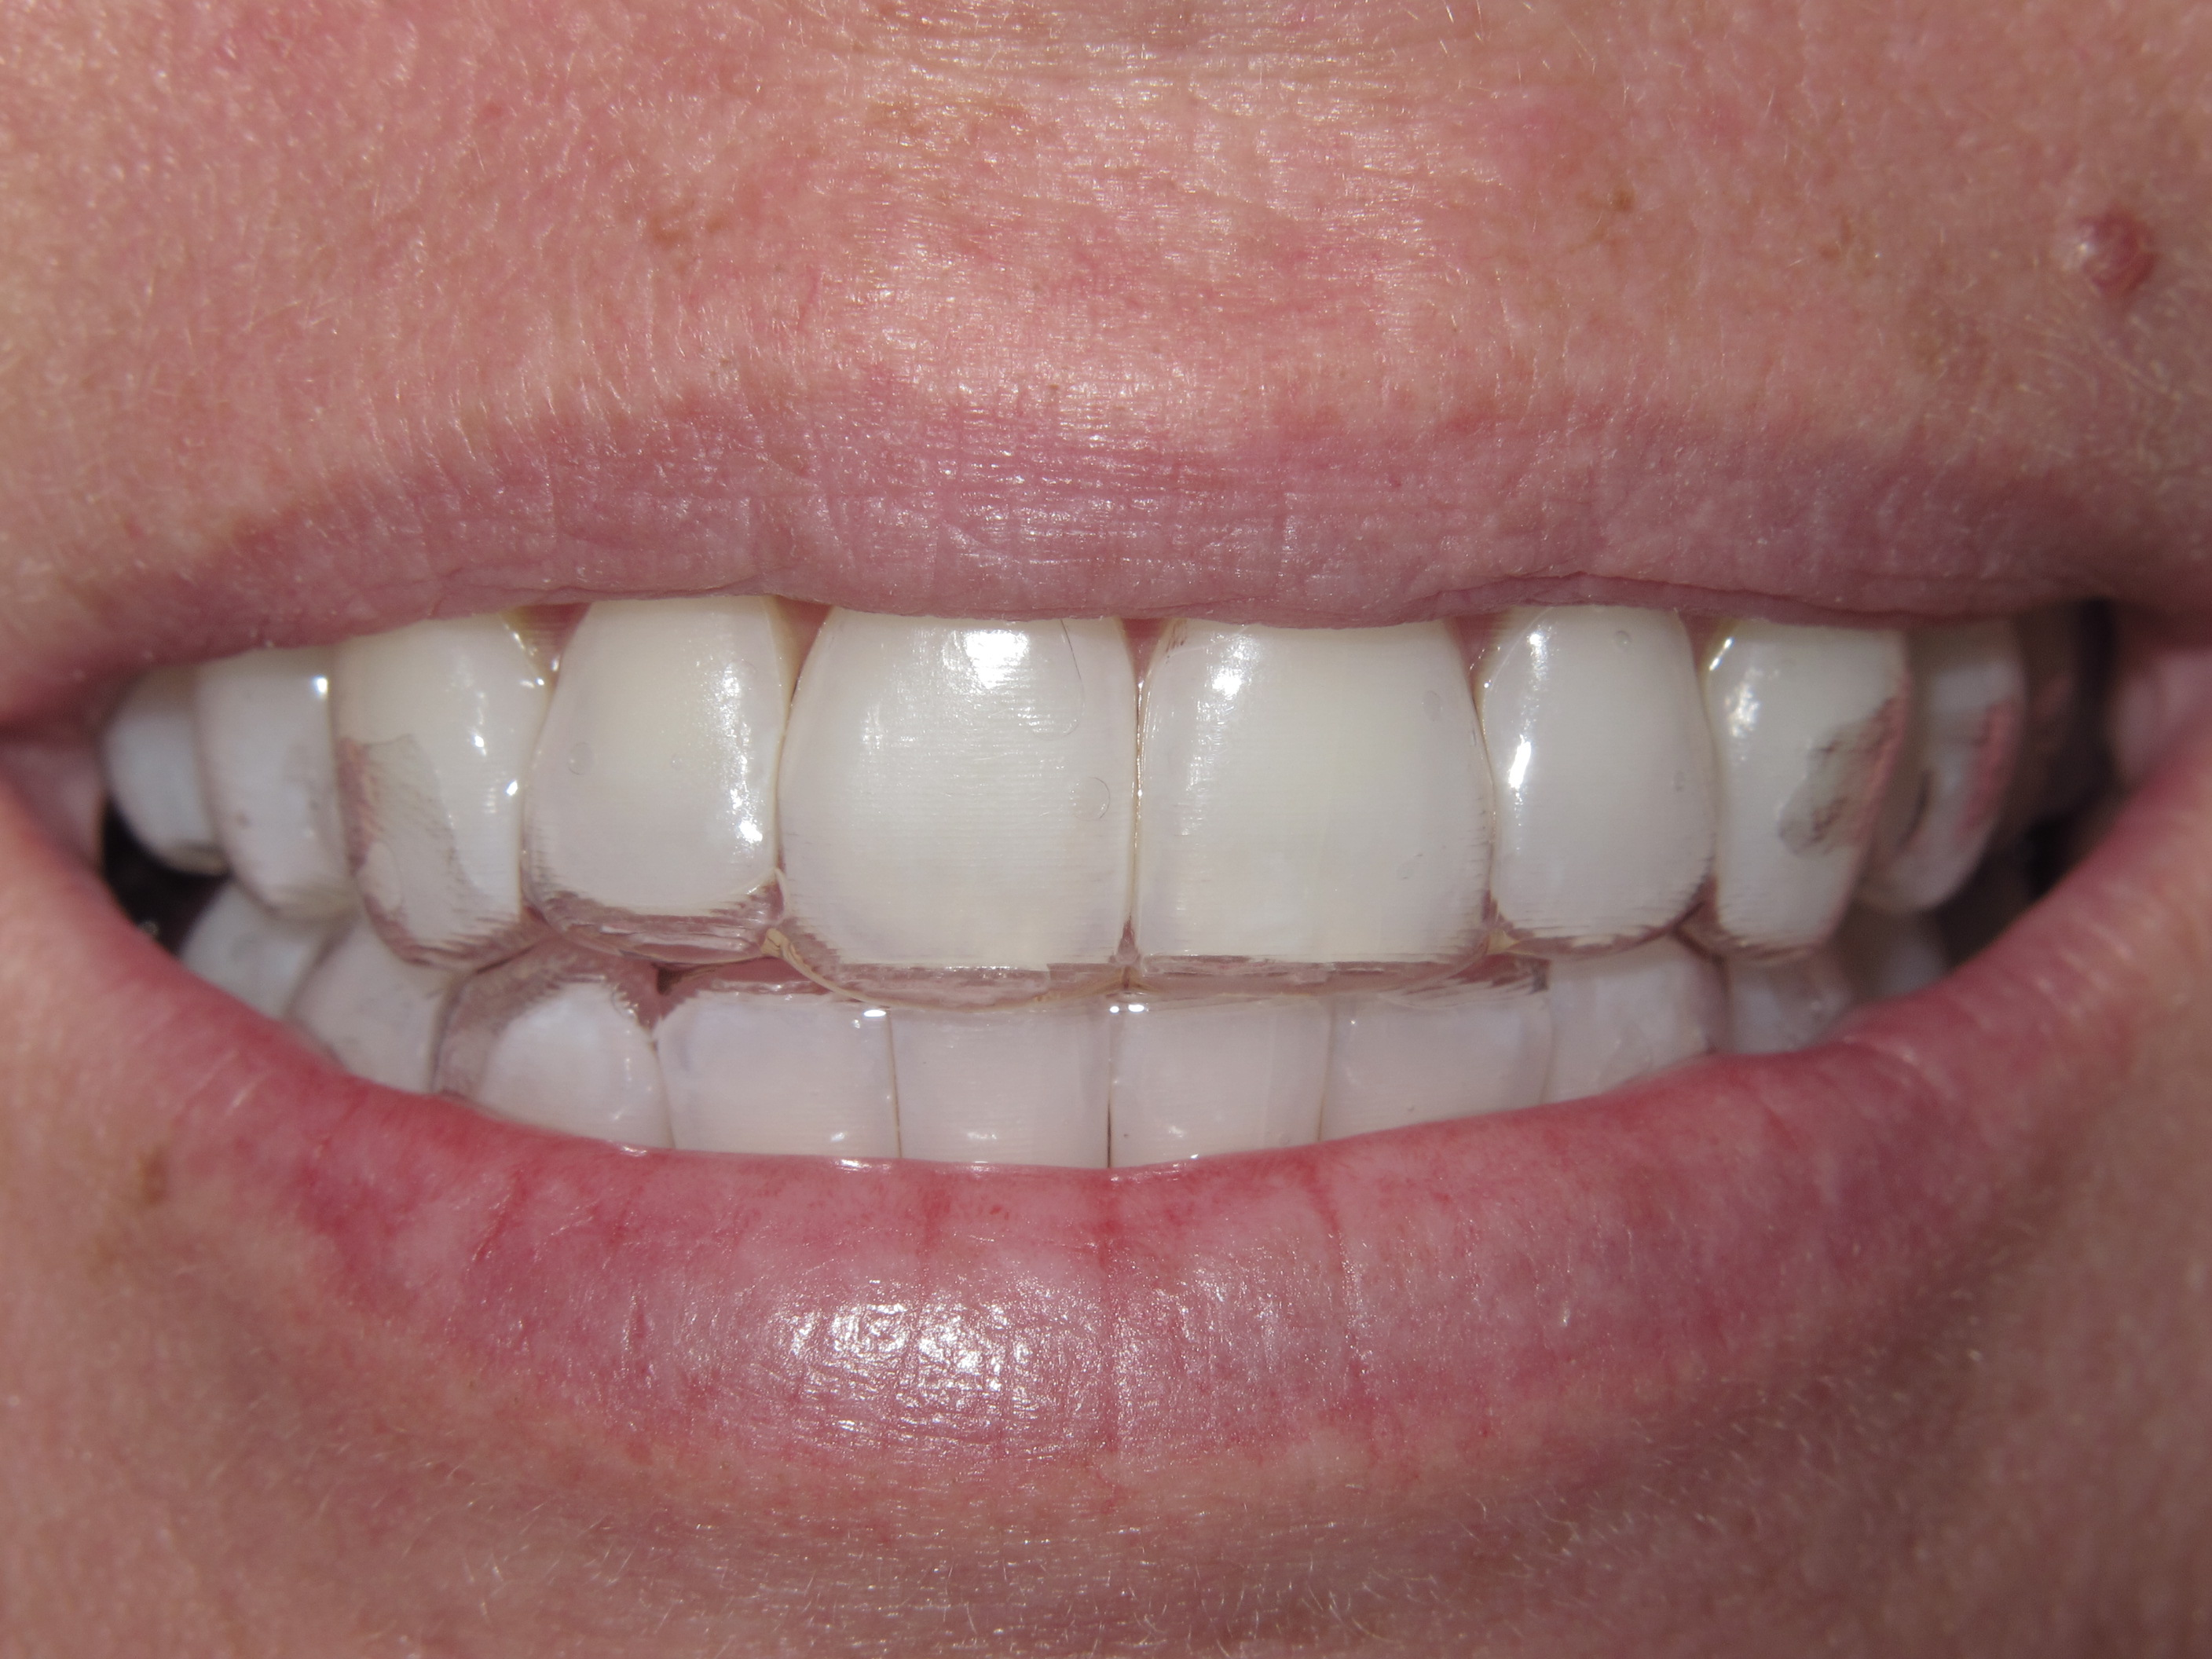
Brackets Invisalign

A lot of parents ask,” What is the difference between Invisalign and traditional metal braces?” The truth is they both accomplish the same goals, which are to perfect occlusion (the way the teeth come together) and to align the teeth to improve the appearance of the smile, but there are definitely some things you should think about when choosing a method of moving teeth. We will discuss the pros and cons of both methods so that you can be informed on what may be the right choice for you or your child.
Traditional wire braces involve using a series of small metal or ceramic brackets and a wire to move the teeth into a particular position. The brackets are bonded onto the teeth with tooth colored bonding material and the wire is slipped through a space in the bracket and held in place by a type of rubber ligature. The movement is accomplished by tightening the wire across the arch to pull the teeth into the desired position. Sometimes rubber bands and/or springs are used to assist in pulling or pushing the teeth into position as well. While this method has been used for generations, there are some difficulties involved when it comes to good hygiene and comfort in both wearing them and having the adjustments.
Metal braces can be fairly rough on the inside of the lips. Tissue may become raw and ulcers can form from the friction they make on the lips and inside of the cheeks. Another challenge to metal brackets is the difficulty they present when trying to clean the teeth. Extra time, effort and tools are necessary to affectively clean around the brackets, and the use of floss threaders is required to enable flossing.
The presence of the brackets and wire make regular brushing and flossing difficult. This presents a larger challenge for teenagers, especially if the teen is already not diligent about homecare. In my experience, I have witnessed the disaster that sometimes occurs when braces are taken off and the patient needs a costly number of fillings because they were not able or sometimes not willing to clean around the brackets. I have seen the disappointment of parents when their child’s braces are taken off and they expect to see a beautiful smile, and all they do see are holes in the teeth.
In the last few decades strides have been made to give patients other options when thinking about straightening the teeth. Invisalign has been available for fifteen years and with over 500,000 cases treated, it has proven to be a very effective way to move the teeth without the appearance of doing so. Invisalign consists of a series of clear aligners that are comfortable and are removable for cleaning and eating. There is no worry about getting food caught around brackets and if relatively effective cleaning is done there is a greatly reduced chance of having to have fillings or additional treatment after completion of Invisalign.
Once you begin, you will receive a few sets of aligners. Each set of aligners is a little different from the previous one and are changed out every two weeks or so depending on what the dentist recommends. He/she will monitor the progression every six weeks and make any necessary adjustments during these periodic visits. Then once the desired position is achieved it is necessary to wear a retainer. These retainers are also invisible and after an initial stabilization period may be worn at night only. The average case takes about a year to complete; however, the length will vary for every individual.
The only limitation with Invisalign is the fact that you can take them off. If the aligners are not worn the recommended amount of time, it simply will not work or will not work as quickly as needed. Another consideration is the possibility of losing an aligner. If an aligner is lost or destroyed it must be replaced to progress forward to the next step so being responsible and keeping up with the aligners is a must to achieve the desired result.
Moving the teeth can be a very easy process. You don’t have to be called brace face, railroad tracks or metal mouth any longer. Invisalign is a simple, easy way to achieve a healthy smile while maintaining your confidence. If you are wondering if Invisalign is right for you my office offers a free consultation so give us a call today. Dr. Tom Wollschlager and his dental team have taken extensive continuing education courses with the Las Vegas Institute for Advanced Dental Studies, the University of Florida and Dawson Institute, and are available by appointment to consult with any patient interested in Invisalign.

