Why Choose Mini Implants?

In my practice I see first hand the frustration that patients feel when dealing with an ill fitting denture. Loose dentures make eating difficult and even uncomfortable. It may cause sore spots on the tissue and embarrassment when talking or laughing and the denture falls or slips. If you are experiencing this problem there is hope. Mini dental implants can stabilize dentures so you can eat, smile and speak with total confidence.
Mini dental implants have been used for many years and in a variety of ways. In addition to being used to stabilize a loose fitting denture, they can be used to replace a single missing tooth, replace several missing teeth or for total dental reconstruction. Their uses are very versatile and can be customized based on the patient’s individual needs.
Your dentist and team will start out by doing a consult; take necessary x-rays and possibly impressions of the mouth. This information will help the dentist to determine how many mini implants are necessary, where placement would be best and evaluate the bone available in which to place the implants. The denture is made just like any other denture and four or more implants (per arch) will be placed in only one visit. This requires only a small amount of anesthetic and is a quick, easy process. The denture is then modified to fit immediately over the mini implants which snap it into place. One of the best things about the mini implant system is that it does not require extensive surgery and the denture is immediately placed and ready for use. You literally can have your teeth replaced in one visit to the dentist. A few follow up visits may be necessary to adjust and tweak the bite, but the process is much less complicated than in years past.
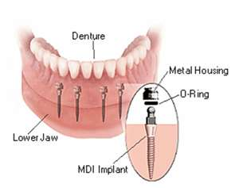
The most significant difference in mini implants from standard implants is that standard implants require several weeks of integration time before they are ready for use. Another difference is in the cost. Mini implants are substantially less than the cost of standard implants, making them a viable option for a wider population of patients. Mini implants are affordable on almost any budget.
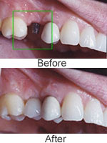
Mini implants may also be used to replace a single missing front or back tooth. This process takes only about 30 to 45 minutes and unlike bridges, there is no need to cut away any healthy tooth structure from the surrounding teeth.
Mini implants are a terrific way to gain a level of stability and confidence for those who already have dentures or who are considering dentures. They have been proven 95% successful when placed by a trained and experienced dentist. If you or someone you know is tired of loose or ill fitting dentures, call Dr. Wollschlager today for a free consult. We have a state of the art facility with the latest and most modern equipment available to provide you with a positive dental experience.

