Common Root Canal Myths

When a patient comes to my office in need of a root canal, I hear them ask all kinds of questions about what exactly is done to the tooth. Many people have misconceptions about roots canal and this article will try to dispel those myths.
MYTH 1- GETTING A ROOT CANAL MEANS THE DENTIST TOOK OUT THE ROOTS OF MY TOOTH. While this is a common thought it couldn’t be further from the truth. A root canal simply means that due to decay or trauma the inside portion of the tooth becomes inflamed and/or the nerve dies. When this happens, the necrotic or dead nerve material must be removed and the canals where the nerve was residing has to be sealed to prevent fluid coming back up into the canal and causing further infection. So really the tooth itself is still there and intact.
MYTH 2- ROOT CANAL TEETH JUST HAVE TO BE PULLED LATER. The fact is that root canal teeth are very strong and can last many years if they are taken care of and kept free of decay. The main thing that causes root canals to fail and the tooth to be extracted is not having a crown placed soon after the root canal is done. When a root canal has been done, the tooth can become very brittle so it is important, in almost every case, to do a crown. The crown covers the entire top of the tooth to hold it together and give support making it very strong.
MYTH 3- ROOT CANALS ARE VERY PAINFUL. Years ago the procedure to do a root canal was not very pleasant but today’s technology has made it a simple process. It usually takes only one visit where before it may take several. Also the files used to clean and shape the canals have been dramatically improved. Some patients, (about 4 %), experience significant pain for a 24-48 hour period and approximately (20%) of patients experience mild tenderness afterward. Most have absolutely no discomfort at all and can resume regular activities right after the procedure is complete.
THIS ILLUSTRATION SHOWS THE STEPS THAT ARE DONE IN MOST ROOT CANALS.
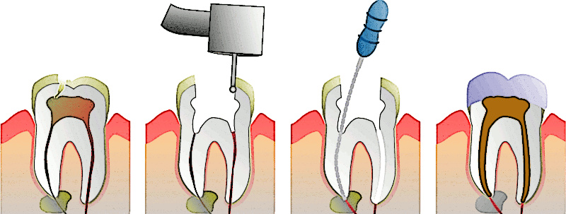
1 2 3 4
Image 1- trauma/bacteria reaching the nerve inside the tooth causing inflammation.
Image 2- a small hole is made to enable the dentist to access the nerve canals.
Image 3- the canals are thoroughly cleaned and shaped.
Image 4- the canals are sealed to prevent the body’s fluids from re-entering at the bottom of the canals and the tooth is reinforced with a crown to provide strength and stability.

While having a root canal can make people nervous, it doesn’t have to be an unpleasant experience. Don’t stress about that root canal!

