Need Tooth Replacement?
Consider Implants

When my patients need a solution to replace their missing teeth due to decay or breakage, I always give them the option to do so with an implant. Implants are the latest in technology available to replace missing teeth and they are now widely used. Using an implant to replace a tooth has many advantages. Placing an implant can stop the bone loss that generally occurs when a tooth is lost, it prevents the surrounding teeth from shifting into the lost tooth’s space which can cause bite problems, and it is not necessary to use the surrounding teeth to hold an implant in. It can be made into a single tooth or more than one implant can be used to work as a unit for bridgework or to stabilize a denture.
A dental implant is really an artificial tooth root that supports a crown or bridge on the top. This artificial root is surgically placed in the jaw bone to then integrate into the bone and anchor the implant body or “new root” in the bone. Implants do not have to anchor to neighboring teeth for support so it is not necessary to “cut down” the teeth next to where the tooth is missing; they are permanent and very stable. Implants are also a great solution to tooth loss because they look, feel and chew just like natural teeth.
Most implants are made from titanium which is a metal that bonds well with bone and is bio-compatible; making it an ideal material for implants.
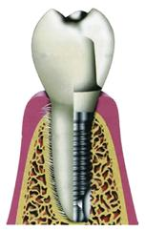
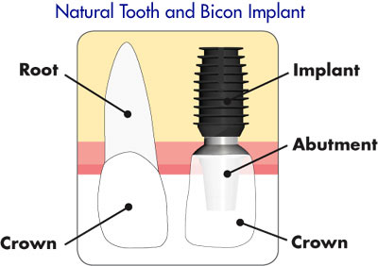

The process to place an implant is easier than you might think. Although each case is different the process generally involves two phases, surgically placing the implant and restoring the implant with a crown or bridge. The surgery may last just a couple to several hours depending on how many implants are placed. The dentist will make sure your mouth is numbed and you are completely comfortable before beginning. During the surgical phase the implant body is placed into the bone and the tissue is sutured. It usually takes several weeks to a few months for your bone to grow around the implant body and for it to become completely stable. An impression may also be taken to place a temporary tooth on the implant body to fill in the space during the healing until the implant is completely restored with a permanent restoration. After the necessary amount of time for stabilization the implant body is ready to be restored. If a temporary crown has been placed, it will be removed and a special attachment is placed on the top of the implant body (called an abutment) and then the permanent crown is cemented on to the abutment. Once this process is complete, the tooth is very stable and secured in the mouth. Your bite will be checked and you are ready to use the tooth in about thirty minutes. The entire process may take a few months to accomplish stability and to restore, but the results are worth the wait.
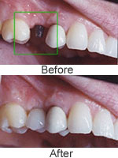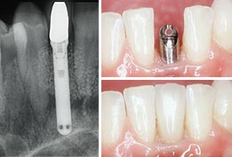

While implants are a great option, they are not recommended for everyone. Placing an implant is a surgical procedure and anyone who is considering it should be in good health, have otherwise healthy gum tissue and adequate bone structure to support implants. However, lack of adequate bone is a limitation but does not make them a non-option. Additional procedures, such as bone grafting may be necessary to improve the implant placement site. The success rate for implants will decrease for people who suffer from chronic problems such as grinding and clenching, or systemic diseases such as diabetes. Also, people who smoke or drink alcohol may not be good candidates as these conditions may reduce healing. Ask your dentist for more information.

