Cracked Tooth Syndrome

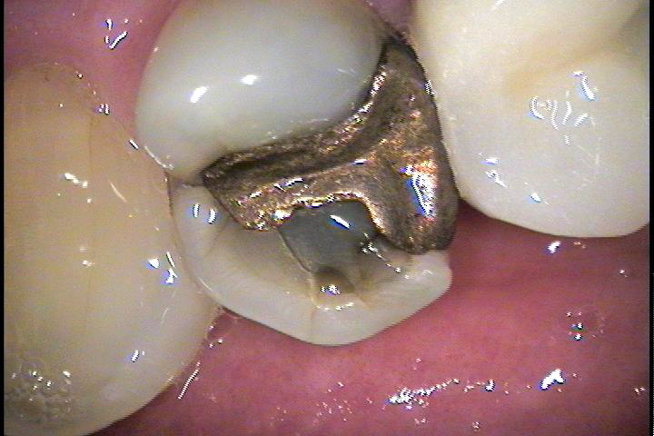
CRACK
CRACKK
Cracked tooth syndrome is a term used to describe a sensation that is felt in a tooth when chewing or biting. Many people describe the sensation as a sharp jolt that lasts a few seconds and then goes away. Teeth can crack due to a variety of factors like chewing hard foods, chewing ice and biting on an unexpected object. Most teeth that crack may already have a filling in it such as silver colored amalgam; however, it may occur in a tooth with no restoration at all. The reason it most often occurs in teeth with amalgam filings is because as we chew on them over the years the metal is malleable and will spread and change shape. When this occurs in the glass like structure of a tooth it will eventually cause a small crack to form. The small crack will then spread like a crack in the windshield of your car. As the crack spreads it becomes larger and deeper thus causing the sharp pain.
The signs and symptoms of cracked tooth syndrome are:
- Sharp jolt pain during chewing
- Pain when cold air is applied or breathed in
- Unsolicited pain
Cracked tooth syndrome is basically your tooth’s response to whatever is happening, such as when chewing. During chewing, especially on something firm like hard chips or bread, the crack in the tooth will flex causing the sharp pain.
When it is discovered that a tooth has a fracture, whether it is giving you pain or not, is the best time to get something done. If your tooth is symptomatic, it may not be long before the tooth breaks. When it breaks sometimes the treatment is simply to remove the fractured portion of the tooth and place a core and crown on the tooth. While many teeth break with little to no pain and no difference in the recommended treatment, it can break deeper into the nerve of the tooth. This not only requires a core and crown it will also be necessary to do a root canal to save the tooth. In some instances, when the tooth breaks, the fracture is so bad that the tooth may not be able to be saved. In that case, the tooth will be extracted and a plan will be discussed to replace the tooth.

