Are Dental X-Rays Really Necessary?

I can’t tell you how many times I am asked that very question. Some patients, for many different reasons, have concerns about having routine dental x-rays. There may be the fear of excessive radiation, discomfort while having the x-rays or even the expense. Dental x-rays are not only useful for diagnosing tooth decay and gum disease, they could even save your life. Certain kinds of dental x-rays can show a hardened carotid artery, a sinus cyst or tumor and bone abnormalities of the face. Even some minor problems such as sinus inflammation and TMJ disorders can be seen on a dental x-ray.
While I do take my patients’ concerns about x-rays seriously, I also take my patients’ dental and overall health seriously. The fact is that a lot of problems that can occur in the mouth and surrounding areas are simply not seen when doing a visual exam only. Most dentists want certain kinds and certain groupings of x-rays to do a comprehensive exam which can include, but are not limited to:

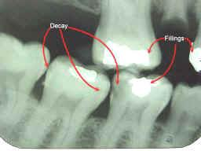
- Bitewings (usually taken in a series of 2 or 4) show the crown portion of the upper and lower teeth in the same picture. These can help identify decay in between the teeth or around current fillings, bone loss and abscess.

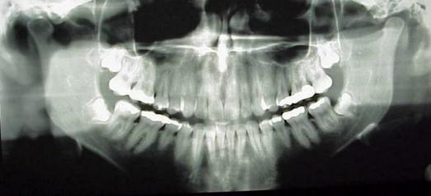
- Panoramic is a large single x-ray that shows the entire dentition including the roots of the teeth as well as the sinuses, the upper and lower jaw, and the TMJ. These can help identify a variety of conditions such as decay, bone loss,
tumors and cysts.

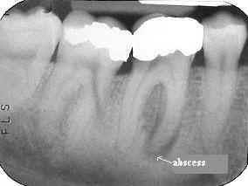
- Periapicals show 1 to 3 individual teeth from the crown to the bottom of the root. They help to identify decay, abscess and bone loss.

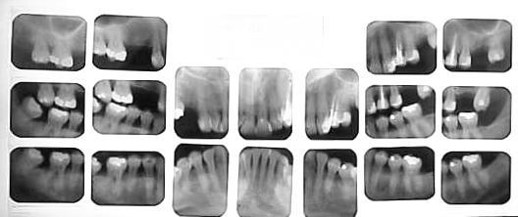
- A Full Mouth Series or FMX - (18-20 periapical x-rays) shows teeth from the crown to the bottom of the root and help identify decay, bone loss and abscess. However, the surrounding structures (sinus or TMJ) are not able to be seen.

The type or number of x-rays the dentist takes is dependant on what type of equipment the dentist has as well as his/her preference. However, most dentists have a certain set of x-rays that will help them with an overall comprehensive evaluation for any new patient, and a set for routine exams for patients of record. Traditional x-rays use a machine that produces very low radiation and film to produce a picture of the teeth. Technology has made it possible for dental offices to provide digital x-rays that produce an image on a computer screen. These types of digital x-rays require very little radiation to produce the image and they are immediately visible. For example, a unit of radiation is measured in “rems”. There are 1000 millirems in 1 rem. A single dental x-ray is only about 0.5 to 3 millirems. You can get more than that by spending the day in the sun. So in short, routine dental x-rays are not only essential for diagnosis, they are safe.
Another concern of many patients is their comfort level when having x-rays done. Depending on the type of x-ray being taken, the x-ray techniques and improvements in equipment have made it more comfortable. We often hear from patients that they have a very sensitive gag reflex and anything put into the mouth will cause them discomfort. I have available in my office a special x-ray unit that only requires the patient to place a small plastic stick in between the upper and lower front teeth to have bitewing x-rays taken versus putting a sensor into the mouth. We also place a soft padded cover over the sensors that must to go into the mouth to alleviate pressing against the sensitive tissues in the mouth.
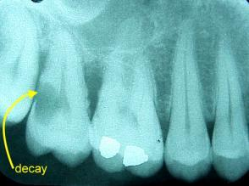
Thirdly, some patients are concerned with the expense of having x-rays. In these times where everyone’s budget is a little tighter it is understandable that people are concerned about expenses, however we believe prevention and early diagnosis is the best way to keep costs down. While having x-rays does obviously come with a fee, the benefits far outweigh the monetary attachment. Many times, with an x-ray I have been able to identify a small problem that requires only a small restoration and thus a smaller investment to fix the problem. Conversely, I have also had the occasion that a patient did not allow an x-ray to be taken and a year later have a very difficult and costly problem on their hands. Many times in these cases the only recourse is to remove the tooth. If the tools needed to identify the problem had been utilized, it may have been identified sooner and loss of the tooth possibly not necessary.
Here is an example of why a visual exam only is limiting. This patient had been a regular patient for three years. He had exams and cleanings every year. He then vanished for three years, finally returning with a toothache. An x-ray was taken and the decay is clearly visible on the x-ray but believe it or not the decay is not clinically visible (ie: just by looking in the mouth). In this case, the decay has reached the nerve, and due to its advanced state, as well as the periodontal (gum) disease also visible on the film, it was necessary to extract the tooth. It takes a LONG time for decay to develop to this extent. Why wasn’t it seen at his last two or three regular exams? In this case, the decay formed between the teeth where it never became visible to the dentist or hygienist. However, it is certainly visible on the x-ray. Why were x-rays not taken at the patient’s routine visits as part of a yearly examination? The answer is that the patient would not allow them to be taken when he came in for cleanings in an attempt to save a few dollars. Though he may have saved some money initially, he really lost in the end because the tooth had to be removed. The cost of yearly x-rays and a filling would have been much less than extracting and replacing a tooth. Don’t let fear or financial concerns cost you a healthy mouth and a healthy you. Talk to your dentist about your concerns.

